SCIENTIFIC JOURNAL
“INNOVATIONS IN PUBLISHING, PRINTING
AND MULTIMEDIA TECHNOLOGIES”

Manuscript submission procedure

Articles for the scientific journal are peer-reviewed.
The continuous publication “Innovations in publishing, printing and multimedia technologies” publishes original and not published elsewhere articles of researchers, academics and practitioners in English.
Article submission and acceptance scheme:

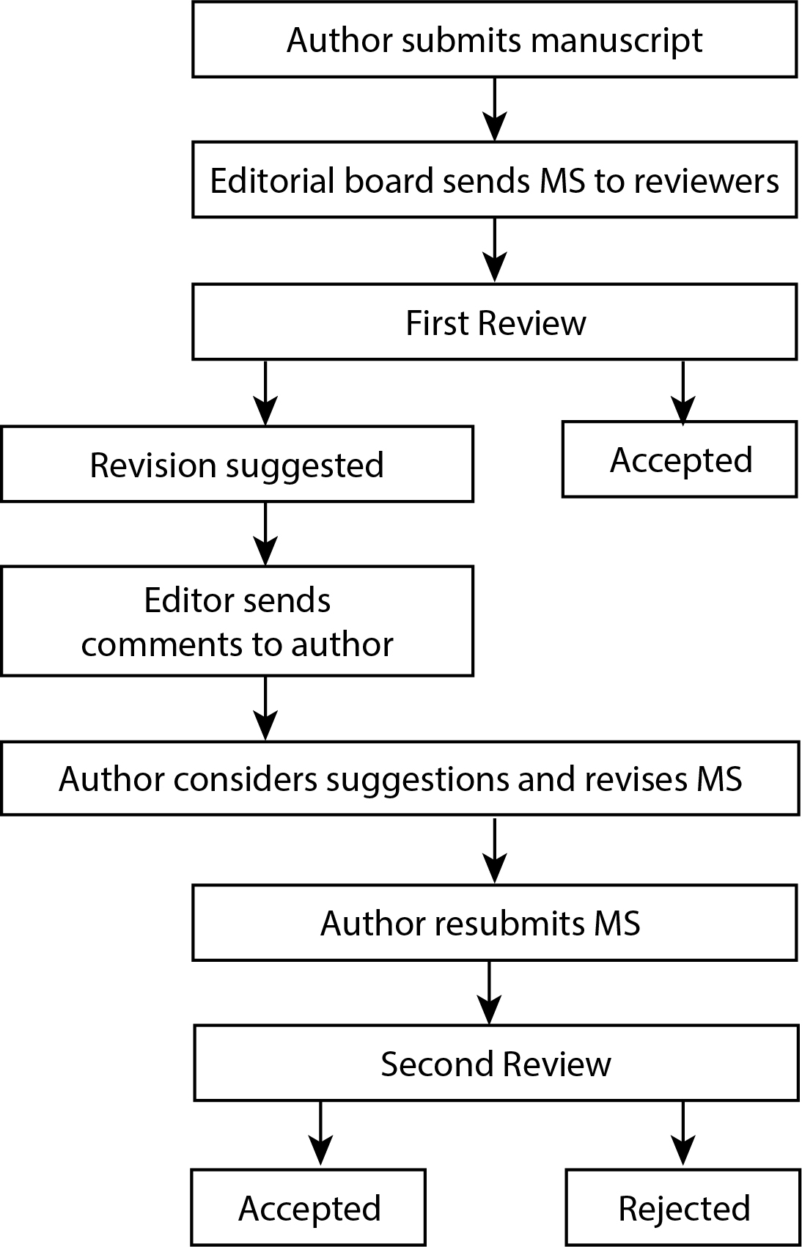

Manuscripts submitted to the editorial board should be written in academic language, and the text should be edited, free of spelling, punctuation, and style mistakes. The article is up to 15 pages A5 (including figures and tables). The manuscripts shall be accepted for publication only if all the conditions listed below are met:
- Authors submit manuscripts that meet the specified requirements. They are responsible for ensuring that the article contains original research data and that the article's co-authors agree on its content and authorship. If a study requires approval from a Biomedical Research Ethics Committee or an institutional research ethics committee, the manuscript's methodology must state that approval has been obtained. After submitting the manuscript, the authors submit the original of the letter of guarantee signed by the authors.
- Reviewers shall be appointed to review the articles that meet formal and scientific requirements. The reviewers’ names shall not be disclosed to the authors. The reviewers shall submit article reviews within two weeks. If necessary, the article with reviewers’ comments shall be returned to the authors for revision. The amended text should be returned within two weeks. If the authors do not agree with the substantial remarks provided by the reviewers, they should substantiate the arguments by sending them to the editorial board in writing.
- The peer-reviewed article shall be published with the approval of the editorial board of the journal.

Formatting requirements

Article should be written in Microsoft Word; the text should be typed on an A5 format page, single spaced, using a Times New Roman 10 pt font, justified. All the margins should be 2 cm.

Title 12 pt, centered, Uppercase, Bold
Authors: surname, initial, 10, centered, Bold
Institution 10 pt, centered, Normal
Abstract 10 pt, left, Bold, abstract’s text 10 pt, justified, Normal
Keywords 10 pt, justified, Italics
Sections 10 pt, left, Bold
The main text 10 pt, justified, 1st line indent 5 mm, Normal
Numeration of tables 10 pt, centered, Italics
Numeration of figures 10 pt, centered, Italics
References 10 pt, justified, Normal

Requirements for the structure

The structure of the article should be as follows:

- Title of the article, the author(s) of the article and the institution(s) represented.
- Abstract. An abstract should contain a short overview of the article content, problem and the relevance of the research, research methods and the results obtained. The text of an abstract must be clear and concise. The length of an abstract is 300–500 words.
- Keywords: keyword 1, keyword 2, keyword 3, keyword 4, keyword 5. (3–5 keywords expressing the most essential features of the topic should be given under the abstract).
- Introduction. The problem of the topic, its relevance and the extent of its exploration, the aim, object and objectives (in case of empirical study) of the research and research methods are formulated.
- Methodology and equipment. This part includes a description of the research methodology, software, analysis of the equipment and materials, and research conditions. In the case of an empirical study, the main part should include a discussion of the procedures/methods of the theoretical framework and hypothesis.
- Presentation of research results (Analysis)
The most important parts of the analysis section can be:
- Analytical research and problem solutions;
- Research results and discussion.
If the article is theoretical, it is necessary to provide a consistent substantiation of the suitability of the selected sources for the solution of a chosen problem.
At the same time, test conditions, parameters and constraints must be indicated, too. Obtained data should be clearly explained with figures and tables.
Presentation of research results can ranger in length from 5 to 8 pages.
- Conclusions
- Conclusions reveal structured results.
- In the case of empirical research, highlight the carried-out activities.
- …
- Recommendations (if applicable).
- List of references
It is recommended to refer to scientific publications from the last 5 years and provide at least 10 references. References have to be listed under the international APA guidelines. The citation of textbooks, brochures, popular magazines, advertising brochures and other similar sources is not allowed.
In the text of the article, sources are cited in brackets by indicating the author's surname and year of publication, e.g.: (Cooper, 2018), (Cleland, Kaufmann, 2012). When the author is mentioned in the text, only the year is written in brackets, e.g.: “... as stated by N. Dageliene (2020)...”. If the Internet source has no author, the reference is added only in the text in parentheses.
- Ku, G. (2008). Learning to de-escalate: The effects of regret in escalation of commitment. Organizational Behavior and Human Decision Processes, 105(2), 221–232.
- …
At least 5 references must be cited in the article.
10. Information about the authors: name, surname. Name of the institution and the department, job position, and research field. Email address: name.surname@institution.xx. Author’s ORCID ID.
11. Research Data Availability Statement. If an article is based on research data, it must include a link to the dataset or specify the conditions for accessing it.
When research data can be made publicly available, it is recommended that the data be deposited in a trusted data repository, assigned a persistent identifier (e.g., DOI), and linked to the dataset in the article (e.g., Research data are available in [name of data repository], DOI: ...).
When research data cannot be made publicly available or access to the data is restricted due to personal data protection; third-party intellectual property rights; professional, commercial, state or official secrets; national security and defense; law enforcement and public safety; or other legitimate reasons, the statement must specify the particular reasons why the data are not made publicly available (e.g., Research data cannot be made publicly available because ...) or why access to the data is restricted. In the latter case, the conditions for restricted access must also be specified (e.g., Access to the research data is restricted because ...; The author may provide the research data upon reasonable request.).
- AI Declaration. If AI tools were used to prepare the article, the tools and their purposes must be disclosed.
- Principles of transparency and best practice in scholarly publishing (https://publicationethics.org/guidance/guideline/principles-transparency-and-best-practice-scholarly-publishing) should be applied to all published content.

